# Question 1:

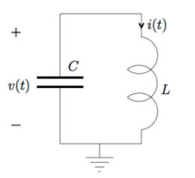

From the prelab we were able to find the following equations for v(t) and i(t):

$$v(t) = -ω_{0}L(I_{0}sin(ωt + φ)$$

$$i(t) = I_{0}cos(ωt + φ)$$

Setting the initial conditions for the capacitor and the inductor to 0 we see no activity in the voltage and the current traces when they are plotted. As the initial conditions we required before the lab both expect an initial condition that is a non-zero value to obtain a non-zero value for $I_{C} and I_{L}$, this would be the result we expected.

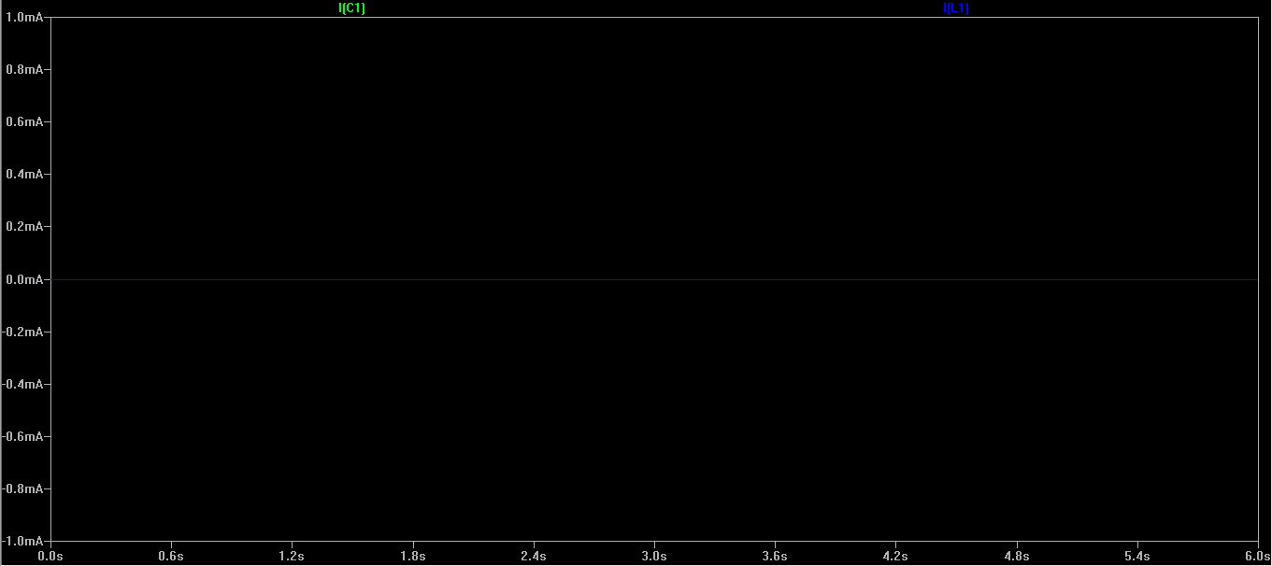

After setting the initial conditions, SPICE produced the graph shown. It shows an oscillation between a positive and negative voltage. The voltage peaks at 10 and -10 volts. The current peaks at around 1.6 and -1.6 amps. Again this is as expected if we plug in those values into the formulae we produced in the prelab. The voltage and current do not decay away as there isn’t a resistance present. The current and voltage also appear to be out of phase. This is due to the inductor, which causes a lagging effect on the current with respect to the voltage across it. Also as the voltage and current are being measured in the opposite direction (minus sign) and one is a sinusoidal and the other is cosinusoidal wave, that is why they appear to be non-inverted.

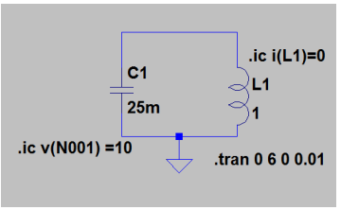

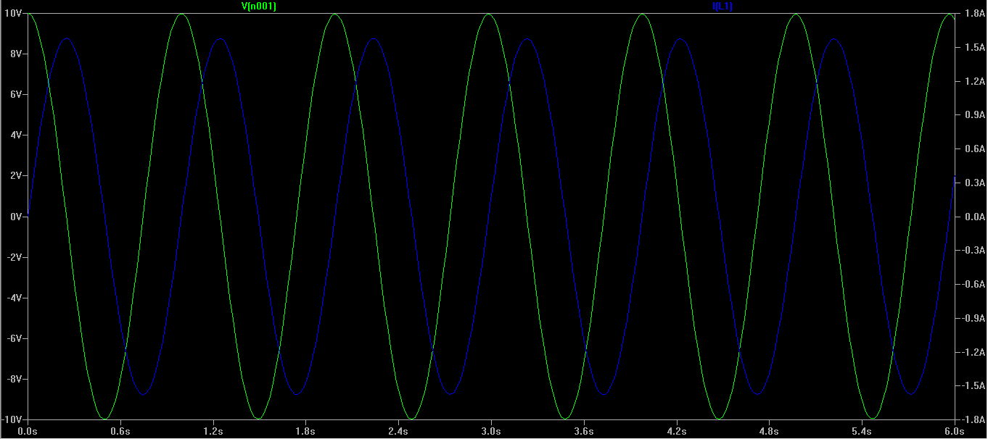

Without setting initial conditions for our inductor, the circuit does not have the relevant information needed to simulate the circuit and so SPICE will generate strange results. SPICE simulated 63 kilovolts and 10 kilo amps. Obviously this is not a realistic result. These results prove why one must be cautious and always include initial conditions for all circuit elements when using a circuit simulator like SPICE.

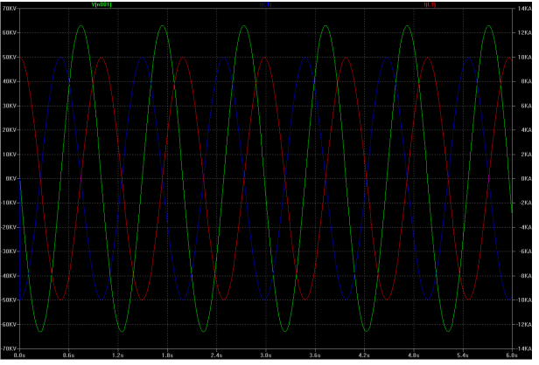

# Question 2:

With the resistor in place, the current and voltage decays to almost 0 over the course of a few seconds, this is called damping. It is due to energy being dissipated over time through the resistor. After approximately 5 seconds we see it reaches an almost steady state. The speed of the decay depends on the magnitude of the resistance of the resistor. Furthermore there would also be resistive elements to our other circuit elements which are not taken into account here. The graph plotting this decay of our RLC circuit can be seen below.

At t=2 seconds Voltage = 637.05 mV Current = -22.478mA

At t=6 seconds Voltage = 0.005V Current = 100uA

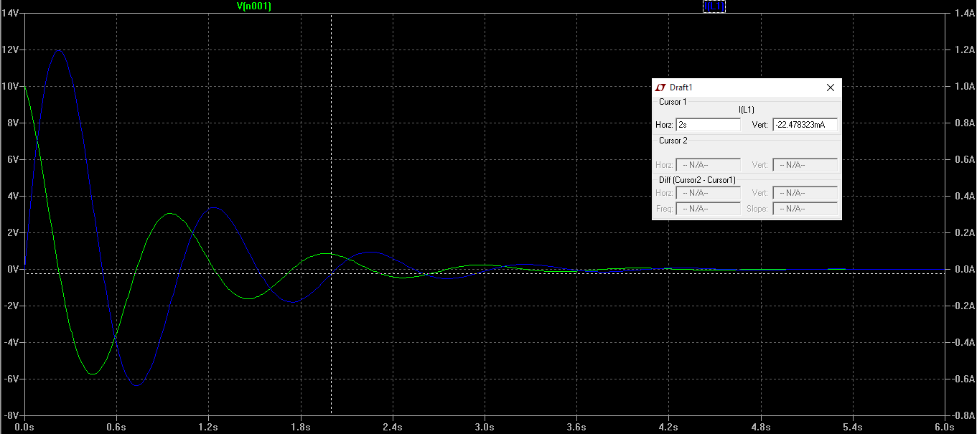

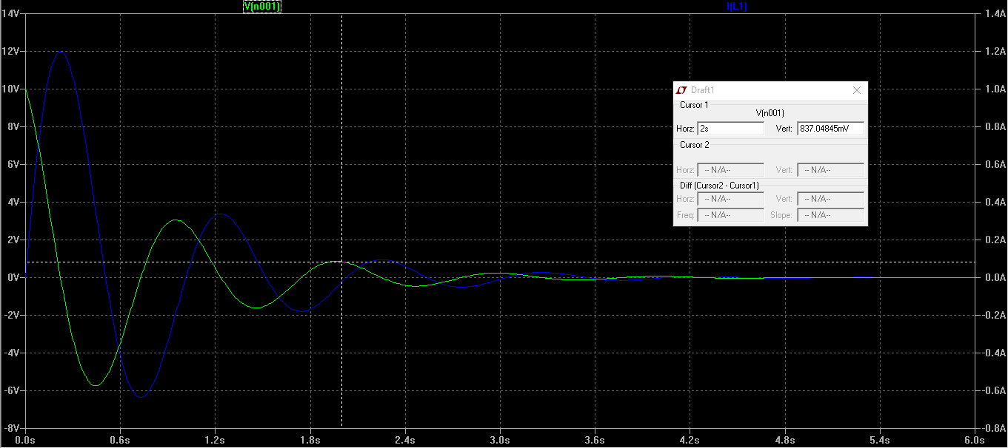

From the prelab we were able to obtain the following equations for $v(n+1)$ and for $i_{L}(n+1)$. :

$$v\left(n+1\right)=\frac{(v\left(n\right)\left(-G+G_{C}+G_{L}\right)-2\left(i_{L}\left(n\right)\right)}{G+G_{C}+G_{L}}$$

$$i_{L}\left(n+1\right)=v\left(n+1\right)G_{L}+G_{L}v\left(n\right)+i_{L}(n)$$

These equations were obtained using the trapezoidal rule.

